
-

Maintaining Balance between sleep and productivity with an AI-based Application



AMERICAN INTERNATIONAL UNIVERSITY–BANGLADESH (AIUB)
FALL 2021-22
BUSINESS COMMUNICATION [FST/FE] [Q]
REPORT

Maintaining Balance between sleep and productivity with an AI-based Application

Submitted by

NAME | ID | CONTRIBUTION

Abstract—This study emphasizes pointing out the challenges in maintaining a balance between sleep and productivity in this age of heavy workloads and finding a fundamental solution to this situation. A survey was conducted on 54 students currently studying at American International University - Bangladesh. This survey was hosted on Google form by preparing a questionnaire, and the link was sent through emails to the students. Open-ended questions and multiple choices are used in this survey. The findings illustrate that about 37% of students pointed to anxiety as their main problem, for which reason they can't sleep well. On the other hand, 22% of students criticized their improper time management as the major reason behind the imbalance between sleep and productivity. Many voted for technological distraction also in this regard. Nowadays, people spend most of their time watching television, scrolling newsfeed of social media, procrastinating, and many more. All of these combinedly affect the proper management of time, which leads people to sleep less. An AI-based application can be very much effective in these circumstances. It will minimize these problems by ensuring a sound environment for sleep and work, which will lead to ensuring the highest productivity.
Maintaining Balance between sleep and productivity with an AI-based Application
Hasan MD. Shawn, Dev Daniel

Index Terms— Artificial Intelligence, Productivity, workload, Technology

INTRODUCTION
IN this age of heavy workloads, people often struggle to maintain a balance between sleep and productivity. Nowadays, there are almost millions of people worldwide who are suffering from a number of diseases related to a lack of proper sleep, like obesity, depression, cardiovascular diseases, etc. Apart from these diseases, some significant problems can be seen. According to Richard J Schwab (2020), 40% of people with insomnia 54% are also believed to be affected by a mental health disorder [1]. Shea Steven A. and Buxton Orfeu M (2018) once stated that optimal sleep increases productivity in academic and corporate life [2]. For many people, a lack of sleep affects their ability to concentrate at work. A considerable number of people cannot reach their highest productivity. Most students of this generation cannot manage their timetable for regular work properly. They struggle to finish their work on time. According to Mp Brundha and Anjali A K (2020), Improper Time management and Procrastination lead students to poor academic achievements [3]. The quality of jobs goes downward. So, it is the basic need of people nowadays to have an artificial intelligence application to balance sleep and productivity. Proper time management will help people both manage their sleep and maximize productivity. Also, it will ensure the proper rest of a particular user.

Methodology
A survey was conducted by preparing a questionnaire and investigating BSc and MSc students of American International University- Bangladesh and their daily lifestyle regarding maintaining a balance between sleep and work productivity. Google form has been used as a platform to conduct this survey. A total of 15 questionnaires were provided to collect information from the students. Multiple choices and open-ended questions were provided so that participants could quickly provide their own opinions regarding any issue. About 54 students participated in this survey. People participated in the survey voluntarily, and the survey was kept anonymous.

Results
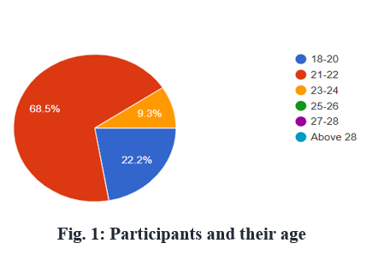
Figure 1 shows the percentage of the age of the participants of this survey. Most of the participants of this survey have ages between 21 and 22 and they constitute about 68.5% of Fig. 1. The second-largest group of participants has an age between 18 and 20 and they cover about 22.2%. The rest of the people are around the age of 24.

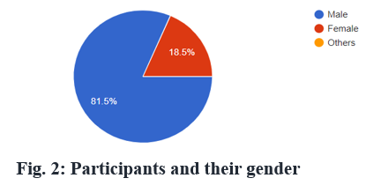
Figure 2 tries to figure out the percentage of the gender of the participants of this survey. About 81.5% of people are male among the participants. The rest of the people are female.

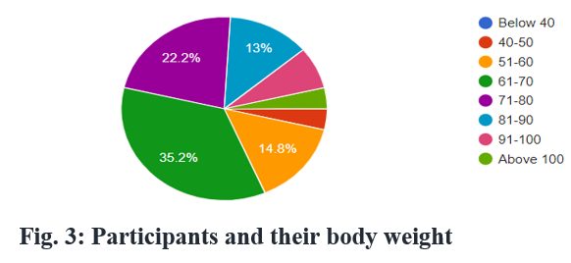

Figure 3 demonstrates the percentage of the bodyweight of the participants of this survey. There is a good relationship between sleep and the bodyweight of an individual. Many researchers pointed to sleep deprivation as a cause of body weight gain. Bodyweight also impacts the amount of sleep. So, it can be said that body weight and sleep are interrelated to each other. And any discrepancy or imbalance in them may cause less productivity. From Figure 3, this survey tried to find out the bodyweight of the participants. Most of the people voted for the weight group between 61 and 70 kg, and the percentage is around 35.2%. The second-largest group of participants voted for 71–80 kg, which is about 22.2%, whereas about 13% of people voted for weights between 81–90 kg. Finally, 14.8% of the total participants voted for the weight group of 51–60 kg. Since body weight puts a significant impact on an individual’s amount of sleep, everyone should try to maintain good body weight.

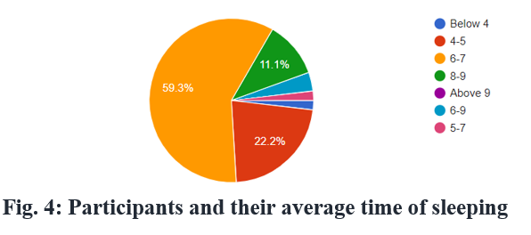

Figure 4 tries to figure out the percentage of the average sleeping time of the participants of this survey. Productivity is directly connected to the average sleeping time of any individual. Sound sleep ensures the highest amount of productivity in most cases. This survey tried to figure out the average sleep time of a targeted group of people. 59.3% of the total participants addressed their average sleep time of about 6 to 7 hours a day, whereas 22.2% of participants sleep 4 to 5 hours on average. The rest of the people (11.1%) said they are used to sleeping about 8–9 hours a day. Usually, every person must sleep at least seven hours a day. But in most cases, some people sleep less than seven hours, whereas some sleep more. Both can have a severe impact on any individual. So, everyone should try to maintain a proper amount of sleep.
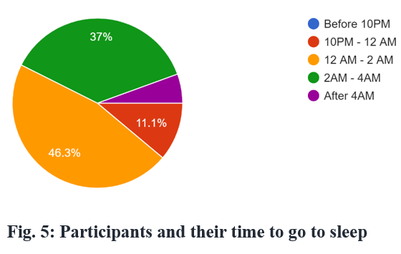

Figure 5 tries to find out when participants usually go to sleep. It is a matter of concern that about 46.3% typically go to sleep between 12 am to 2 am. Also, 37% of people go to bed very late. They usually go for asleep between 2 am and 4 am. On the other hand, only a small portion of the participants go to bed between 10 pm to 12 am.

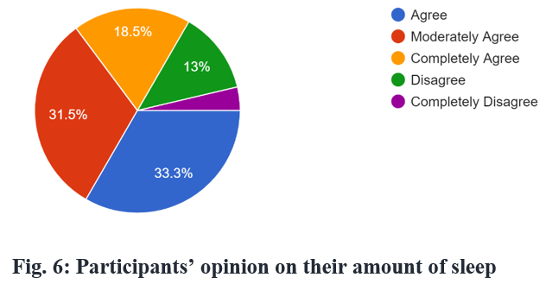

This figure 6 focuses participants’ opinion on the amount of sleep they everyday have. Only 18.5% people completely agreed that the amount of sleep they have is sufficient whereas almost 13% people disagreed. About 31.5% people moderately agreed and 33.3% people just agreed that they have enough amount of sleep. To get an optimal performance, an adequate amount of sleep is a must.

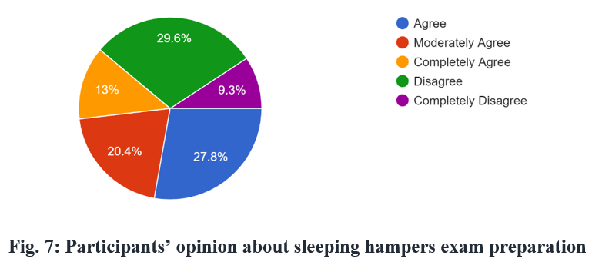

From this figure 7, it can clearly be seen that most of the people agreed that sleeping hampers their preparation. About 27.8%, 20.4% and 13% of people voted for agreeing, moderately agree and completely agree on this issue. Whereas 29.6% and 9.3% of people disagreed and completely disagreed with this issue respectively. It is a matter of great fact that during exams, not only good preparation is needed but also sound sleep is necessary for a sound and healthy preparation.

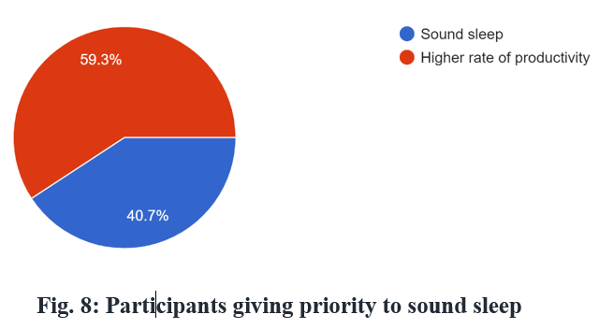

Figure 8 displays what participants usually prioritize the most during exams or heavy workloads. About 59.3% of people put a higher rate of productivity on the top, whereas 40.7% of people prefer sound sleep to productivity.
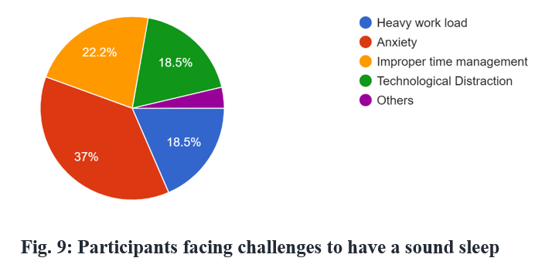

Figure 9 tries to find the main challenges participants usually face to have a good amount of sleep. About 37% of people voted for anxiety as their main reason behind not having proper sleep. A good number of people of 22.2% voted for improper time management whereas 18.5% people voted for heavy workload as their main challenge. Another 18.5% of people pointed to technological distraction as their main problem to maintain a good amount of sleep.

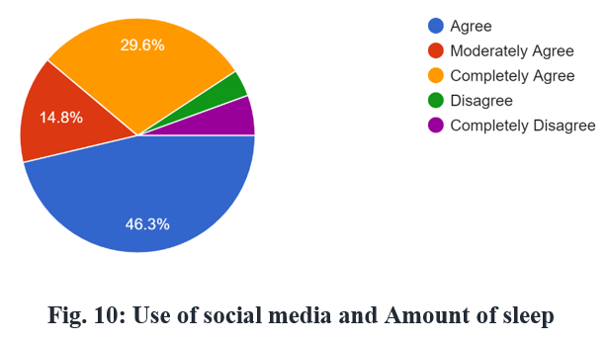

Nowadays, most of the people spend a good amount of their time scrolling the pages of social media which leads them to improper time management. This results in having an inadequate amount of sleep. This figure tries to look for the opinions of the participants regarding this issue. Almost half of the total participants agreed on the issue that overuse of social media compresses their time slots on other works, most importantly, the amount of time of sleep. Also, 29.6% of people completely agreed whereas 14.8% moderately agreed on this issue. About 9% of people partially or completely disagreed.
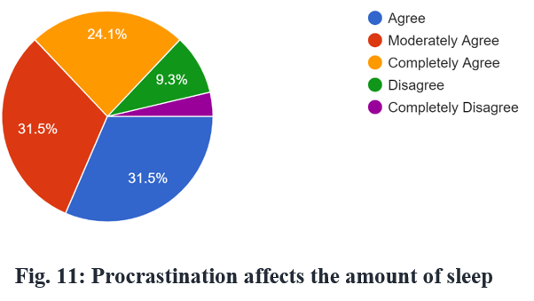

Figure 11 tries to demonstrate how procrastination affects the amount of sleep people have. About 31.5% of people agreed that procrastination affects a lot in maintaining proper sleep. Another 31.5% of people moderately decided on this issue. 24.1% of people ultimately agreed, whereas 9.3% of people disagreed on this issue.

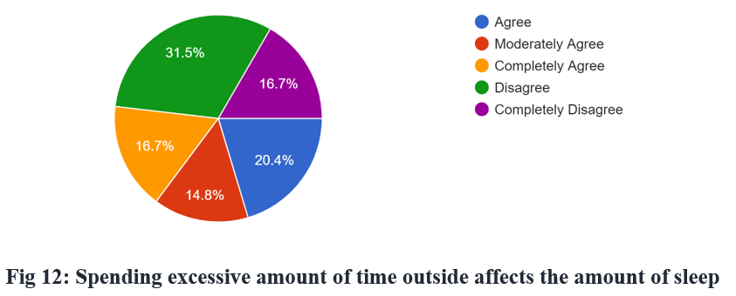

Figure 12 tries to point out how spending too much time outside affects the time of sleeping as well as figuring out opinions of the participants in this regard. About 31.5% of people disagreed with this. Also, 16.7% completely disagreed while 51.8% people completely or partially agreed on this issue.

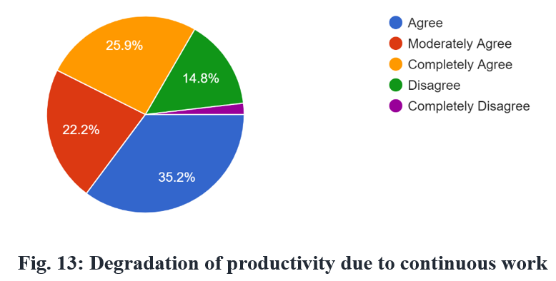

Figure 13 tries to figure out how productivity is affected by continuous work. In this age of heavy workloads, people are bound to work continuously. Sometimes it can be seen that continuous work lower the quality of tasks completed. In our survey, about 25.9% of people completely agreed that a higher rate of continuous work degrades the quality of work. It lowers productivity. Additionally, more than 55% people of the participants moderately agreed with this issue. Only a few people disagreed with the people who agreed.

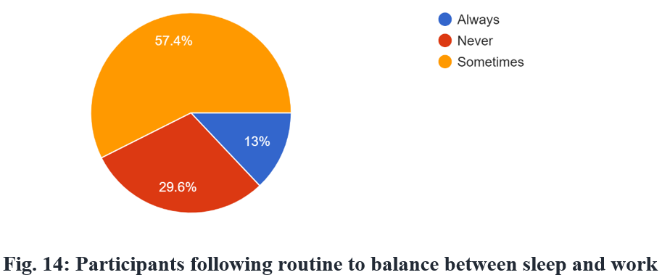

Figure 14 tries to determine how many people usually use a particular routine to balance sleep and work. Most of the people sometimes try to maintain a balance with a routine and their portion is about 57.4% while 29.6% never use any particular routine for this. Only 13% of the total participants use a routine to maintain their tasks and peoper rest.

Recommendation
To maintain the daily life of a particular individual, the importance of an AI-based application is a must nowadays. According to Poola Indrasen (2017), In today's world, Artificial intelligence AI is progressing rapidly and making people's life easier. By using this app, everyone can balance between workloads and proper rest. In this application, there are some certain features that will guide a user to arrange his schedules for ensuring the highest productivity in each work and balancing sleep as well. This system will be connected to all the electronic devices in his workplace and home through a wireless medium. It will perceive users' actions by the sensors available with those devices. The internet, AI, and wireless technology growth make it easy for users to personalize home applications like Alexa, Apple, and google voice assistant [5]. In our proposed system it will not only be confined to voice command rather it will monitor all the devices and give decisions based on that. Here is the workflow diagram of the proposed system.

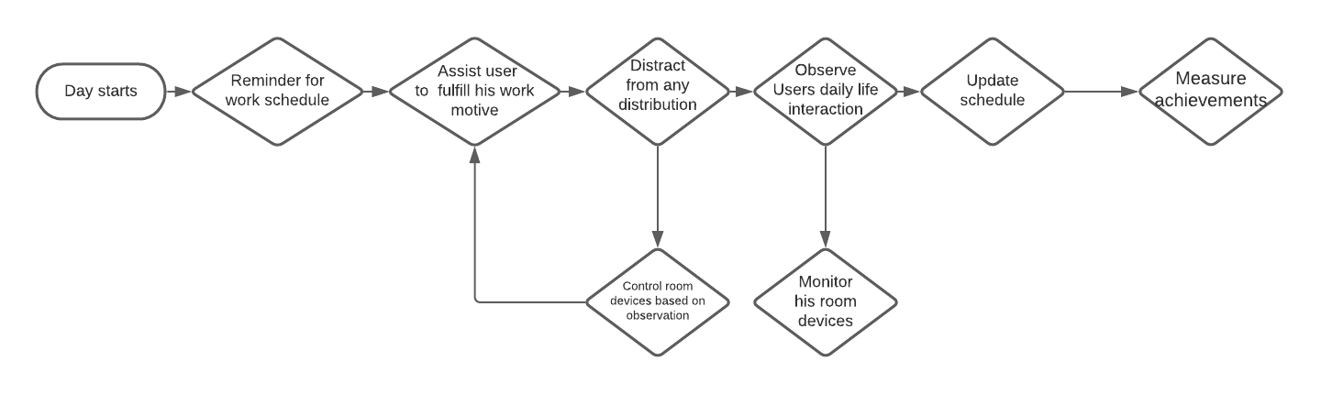Here are some features that the application will provide:

- Notify users timely about their work schedules.
- Keep users distracted from any unwanted disturbance.
- Control devices with voice commands.
- Maintain the environment by controlling room temperature.
- Control devises to reduce excessive use.
- Calculate the achievements by monitoring his task progress.
- Observe user's interactions and update the service methods.

Conclusion

This proposed system is beneficial for any person having electronic devices. It will help them maintain their daily life properly and achieve their goals. People having physical disabilities will be also be benefited from this system as it has a voice command system. It will slightly erase their hardships to deal with every obstacle.

References
- Richard J Schwab, MD. (2020). Insomnia and Excessive Daytime Sleepiness (EDS)Available at: https://www.msdmanuals.com/home/brain,-spinal-cord,-and-nerve-disorders/sleep-disorders/insomnia-and-excessive-daytime-sleepiness-eds
- Mp Brundha and Anjali A K (2020). A Survey on Time Management Among Students of Higher Education Available at: https://www.researchgate.net/publication/348013987_A_Survey_on_Time_Management_Among_Students_of_Higher_Education
- Shea Steven A. and Buxton Orfeu M (2018), Optimal sleep increases productivity in academic and corporate life. Available at: https://www.researchgate.net/publication/328413888_Sleep_work_work_sleep

- Poola Indrasen (2017), How Artificial Intelligence in Impacting Real Life Every Day Available at: https://www.researchgate.net/publication/321348028_How_Artificial_Intelligence_in_Impacting_Real_Life_Every_day

- Al-Amin MD. (2016) Design of an Intelligent Home Assistant. Available at: https://www.researchgate.net/publication/315364882_Design_of_an_Intelligent_Home_Assistant

 

